**Apache Kafka**

Kafka JavaTeche(youtube)

**-----------------------------------------**

What is Kafka?

- It is an open-source distributed event streaming platform.

Event stream:

- Create real-time stream: sending stream of continuous data from paytm to kafka-server

- process real-time stream: continuous listen/reading the message from kafka server and processes them

Distributed:

* Distributed the kafka server means if any one server is down then other server can pic-up.

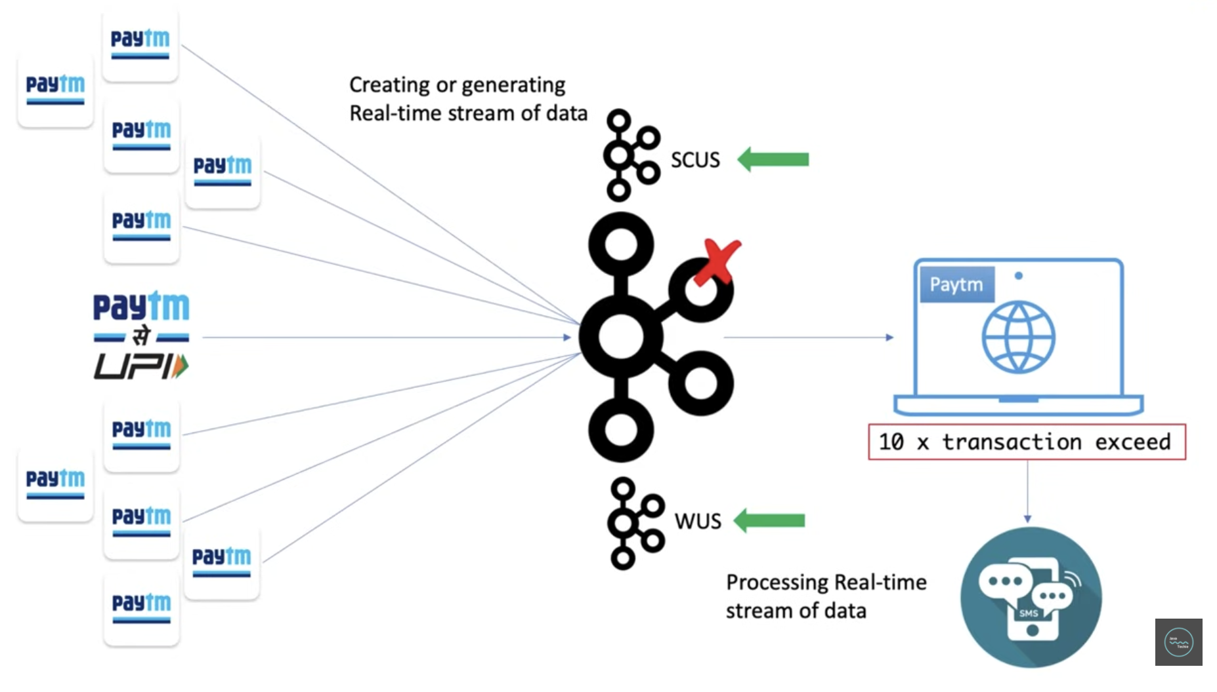

Where does kafka come from?

* Kafka originally develop by LinkedIn, now Apache foundation has accommodated.

Why do we need the kafka?

* I have some parcel on my name so postman come to my door to deliver the parcel, unfortunately I was not there in my home went for vacation, he returns back and he tried 2-3 items to deliver the parcel and every time I was not there in home after some days he forgot about the parcel or he return the parcel in main office, in this case I lost the data what postman doing to my door and this could be a huge lose for me.

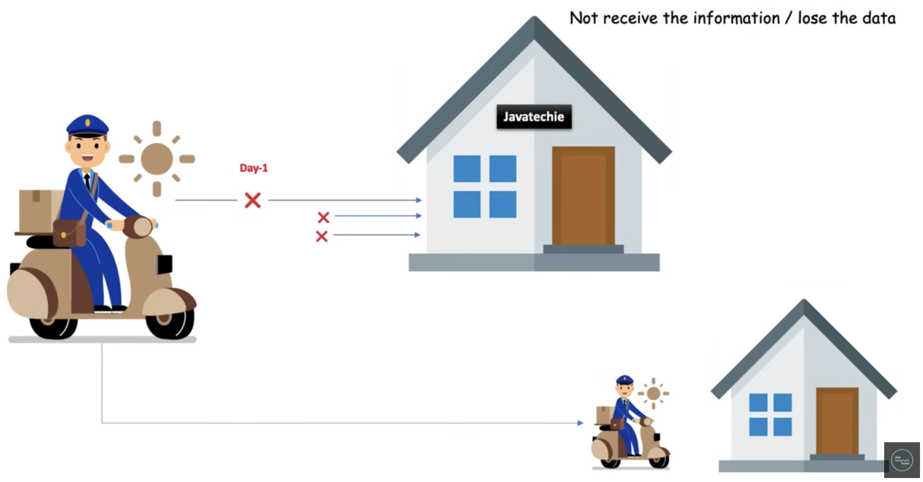

* To overcome this issue, I have installed latter-box at my home door so when next time postman bring to my parcel for me and if found I am not there in home then, simply he put my parcel in letter-box so whenever I back to my home I can go to letter box and collect the parcel/message what postman dropped in my letter-box, in that case I will not lose my data, data will be there until I pic it up. Here letter-box acts as middle man between postman and me,
* let see in the real-time example there is two app and app1 send the data to app2 and if app2 is not available to receive the data again he lose the data like me which might impact business of app2 so to overcome this communication failure we might need to install something similar to letter-box between 2 app that is where Kafka com into Picture, you can add messaging system between them and this messaging system can we kafka/RabitMQ/Raddish so in case even app2 is not available but he can collect the message from kafka whenever he come online hence he cannot lose the data.

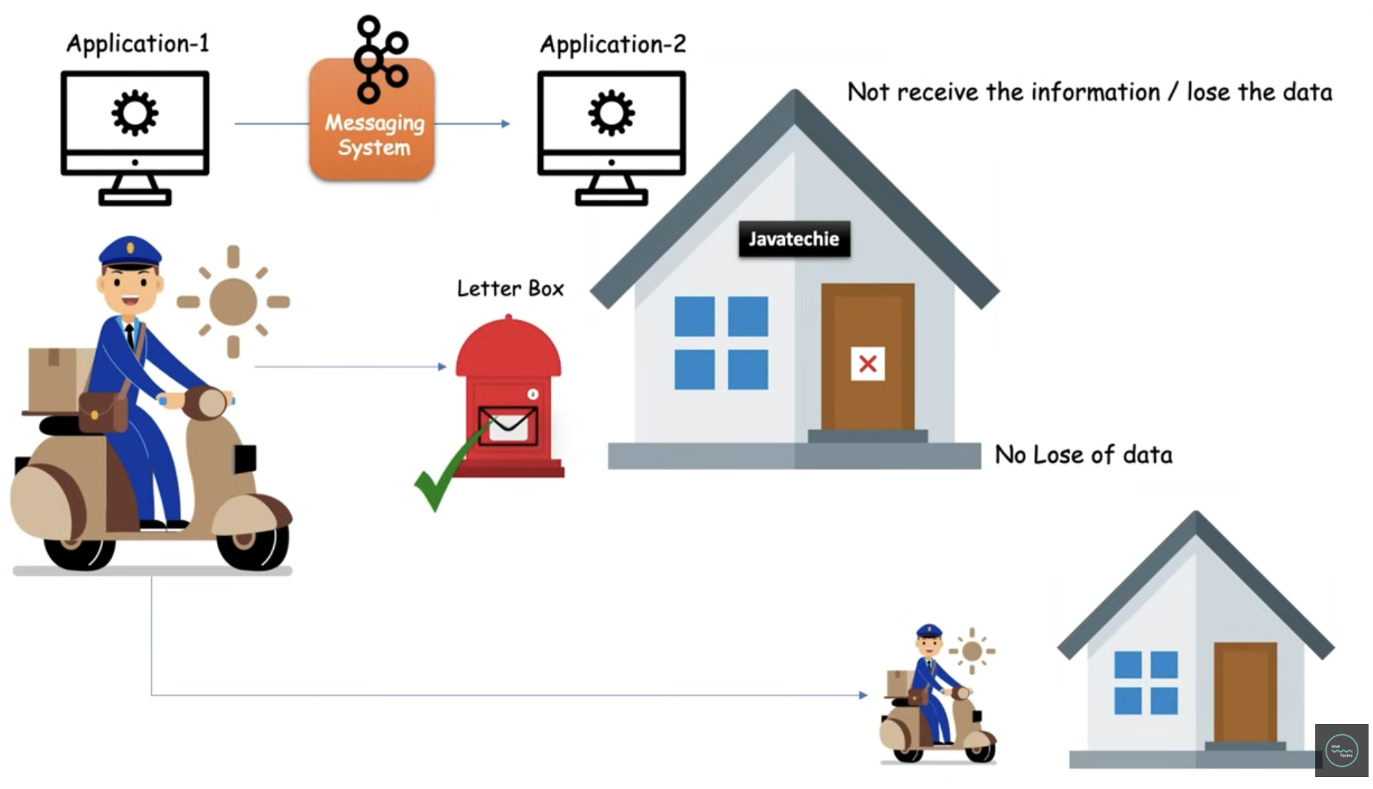

* Let see in more complex scenarios, Let’s say you have 4 applications who want to produce different data to the database server this looks simply and no such problem but in your future application s can grow you might have n number of service to communicate with each other in that situation its really tough to manage these many connections between services there could be a lot of challenge such as
* **Data Format** – Frontend app may be wanted to produce diff type of data to each different type of applications, may be frontend app want to send some payload structure to Database-Server or some different payload structure to security-systems similarly Hadoop also might to send some different type data and so on…there could be complexity to handle the data format or schema.
* **Connection Type –** there could be different type of connections, it could be http/tcp/jdbc means connections type will be complex to maintain with multiple services
* **Number of connections -** each 4 application connect to others means if you count the number of connections here is 20, to just maintain or communicate we need to manage the 20 connections, in Enterprise Application really its kind a bottom neck situation to handle these challenges. To over this issue kafka come into picture.

` 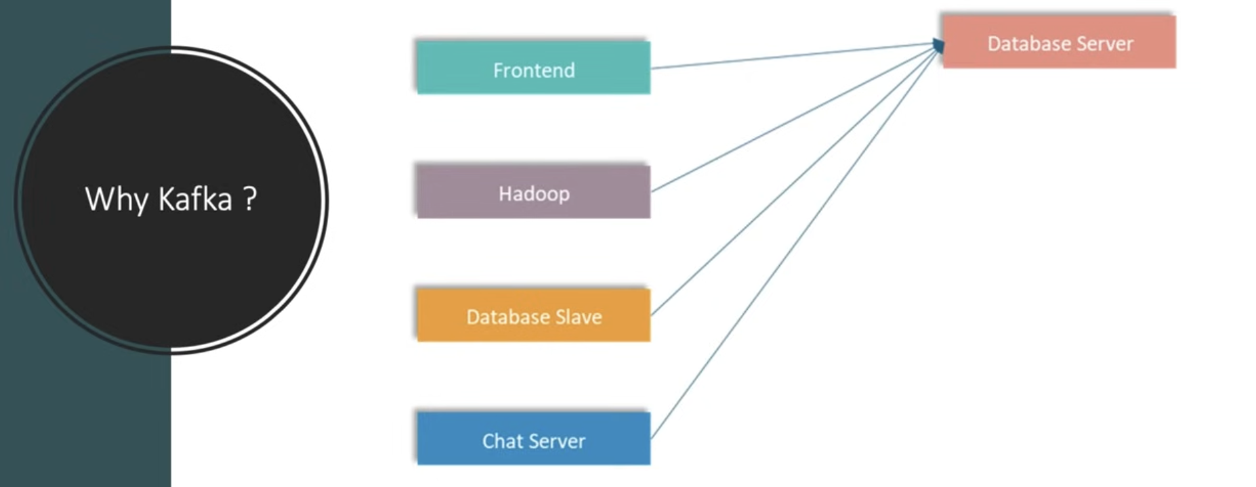

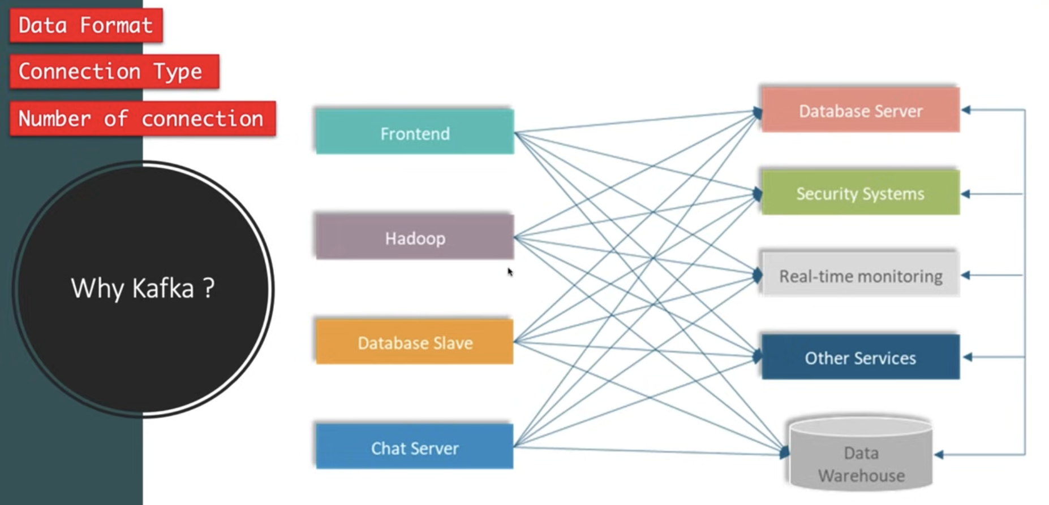

* Using the **kafka**, all 4 application whatever data-type/schema-structure or connection-type they have simply send to the kafka-server and which kind of data data-server need ll go to kafka-server and directly get from kafka-server similarly security-system want to fetch some data given by either Hadoop or database-Slave he simply go there and check what he was looking for and get it from there as so on… in this approach all 4 application dropping the message in central kafka-server so we have reduced the number of connection like instead of 20 we use 9 connections only.

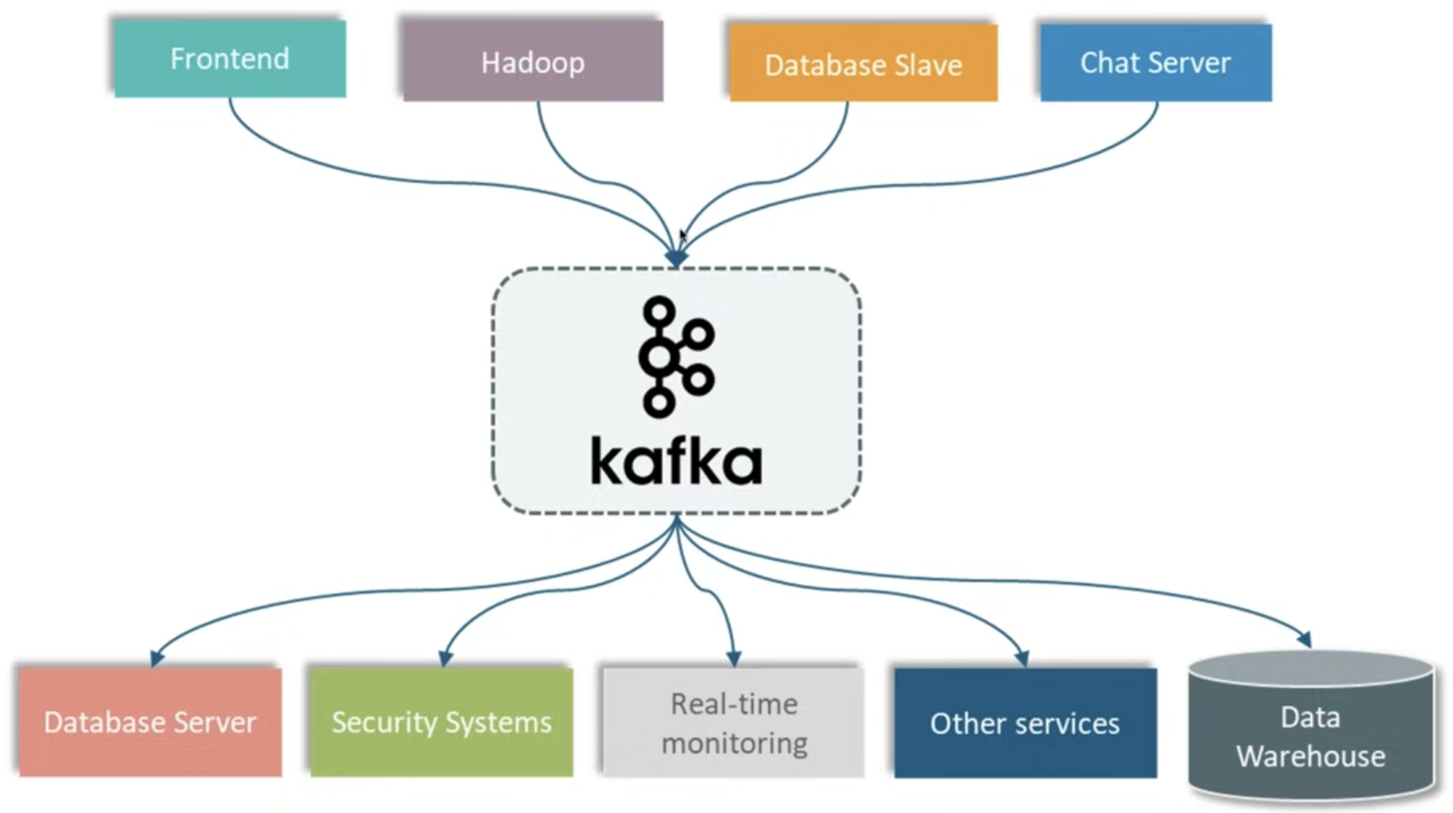

Kafka components

---------------------------------------

**Producer**: It publish the data/events on broker (kafka-topic)

**Consumer**: It subscribe/consume the data/events from kafka broker (kafka-topic)

**Broker**: It is a server. It an intermediate entity that help in message exchange between a producer and consumer.

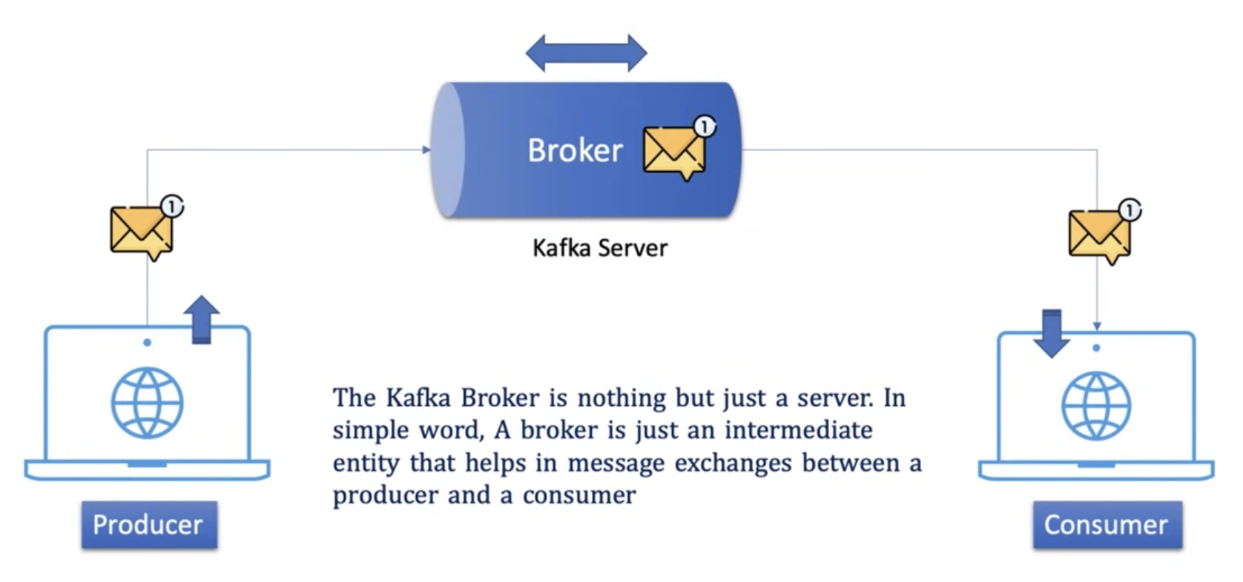

**Cluster**: It is group of brokers, let say publisher sent the huge volume of data then single kafka-broker cannot be handle the load so you might need to add the additional kafka broker.

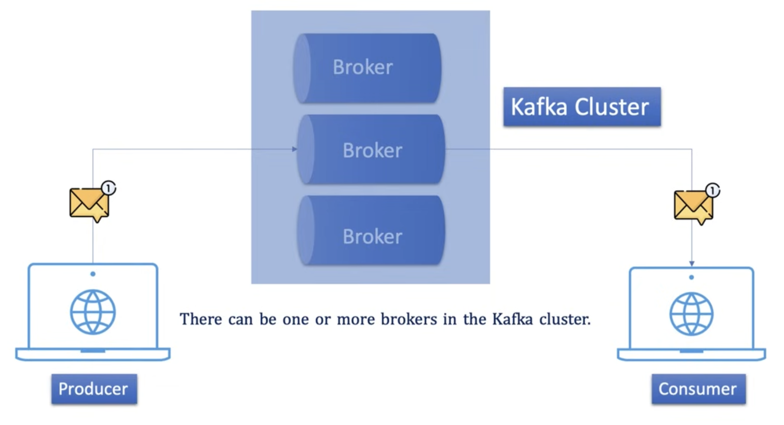

Core components of Broker

----------------------------------------------------------

Why **Topic** inside in the broker?

* Consumer ask to the broker hey give me all message you receive from publisher then broker check the storage and replay to the consumer hey consumer I have lot of messages with me which one you need, again consumer ask give me all payments specific message again broker attach the counter Q hey buddy I have diff type of payments message with me which one you need now its gone right…consumer heard counter Q, then we can overcome this back and forth conversation that is where **Topic** come into picture to categorize diff type of messages so how topic help here you can simply create multiple topic to store different type of message like payment-topic, booking-topic, insurance-topic to receive and send the message from this specific topic.

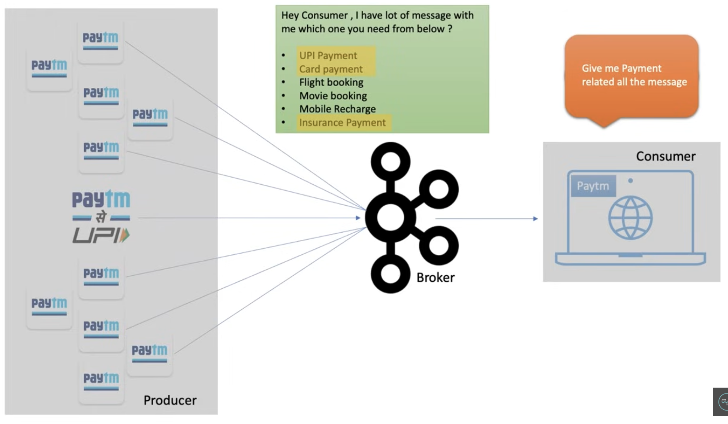

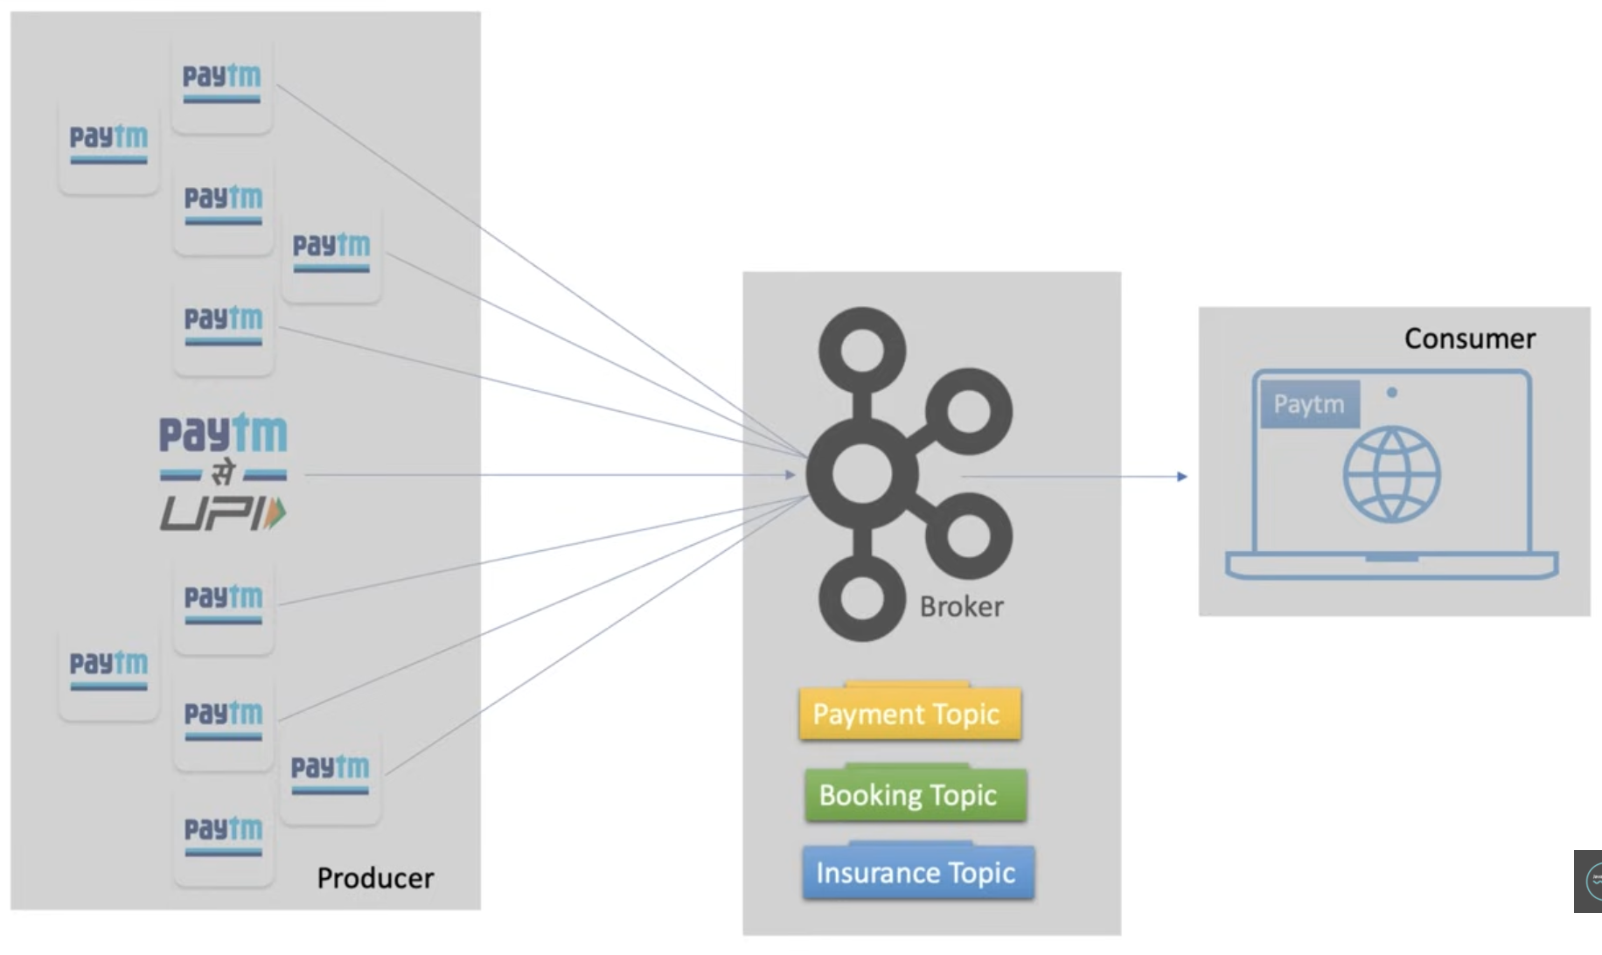

* Usually, we store the emp info in emp-table and payment info in payment-table in database world similarly when producer send employee/payment specific message we need to store into employ-topic/payment-topic, if you have multiple consumers then they can directly go to specific topic and consume the message as per there need no need to ask the broker hey broker give me the employee/payment specific message.

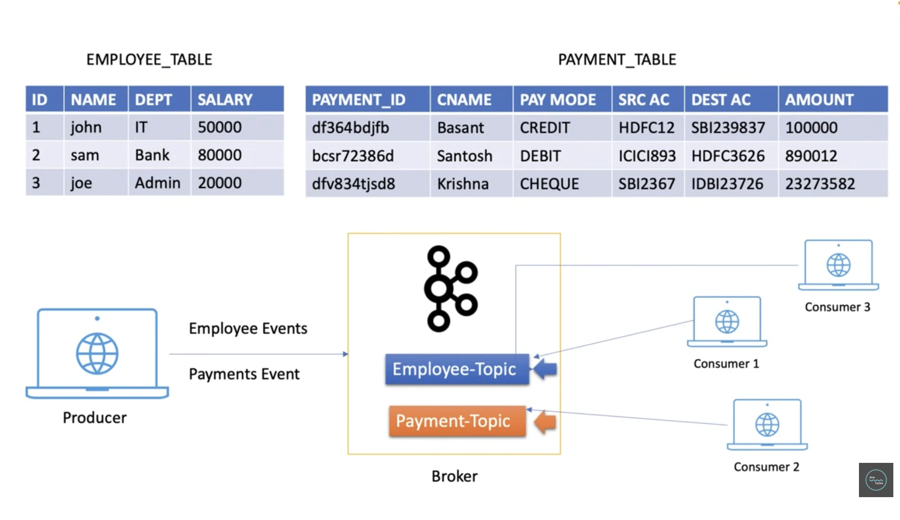

**Topic**: It specify the category of message or classification of message; Listener can just respond the messages that belongs to the topics they are listening on.

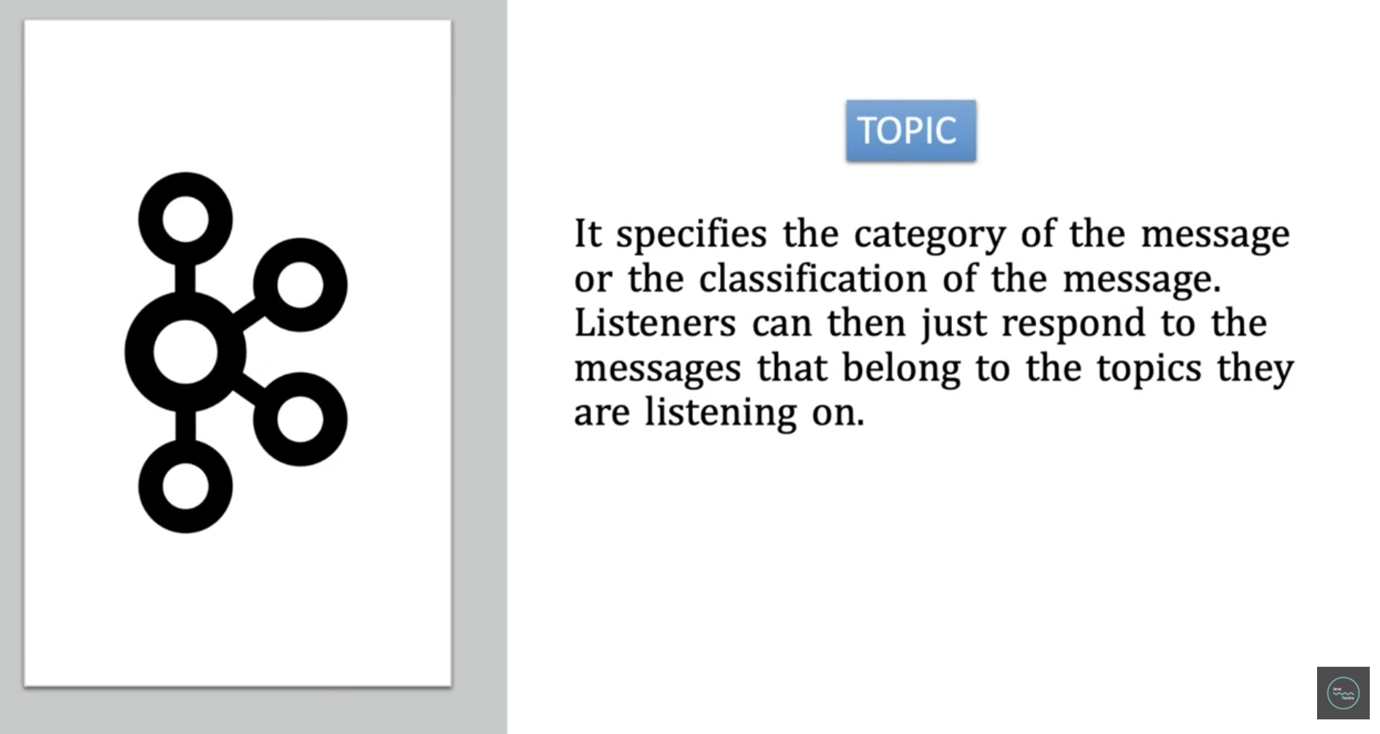

**Why Partitions?**

* When producer send the huge volume of data to the kafka topic then in this case topic might not able to handle this data then **partitions** come into picture, as you know kafka is distributed system in such a scenario we break the kafka topic into multiple parts and distribute those parts into diff machines this concept called topic partitioning and each parts called is **Partition** in kafka terminology, this partitioning give you better performance high availability because when producer produce bulk of message then each partition concurrently accept the message that definitely improve the performance even in case any partition goes off then other partition are available to handle the load without application downtime, we can decide the number of partition of topic during kafka topic creation.

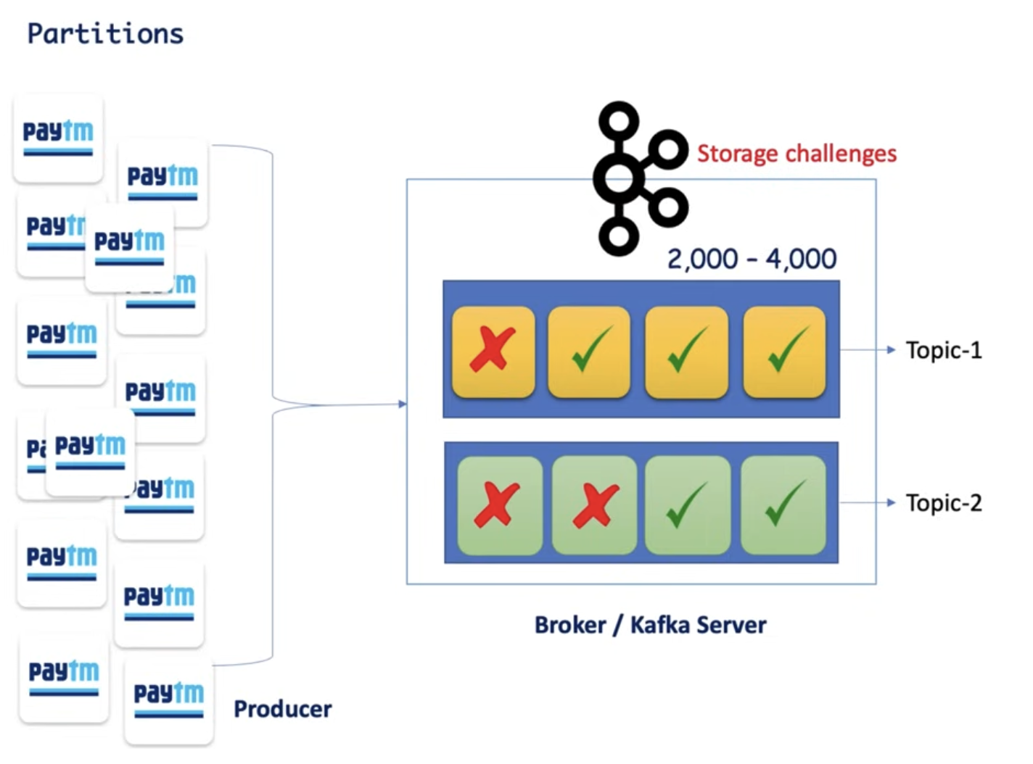

**Why Offsets?**

* Consumer, after reading 4 messages from partitions the consumer went down and when consumer back to online then this offset value is help him to know that from where need to start reading the message.
* The purpose of offsets is kept track of which message already consume by consumer.

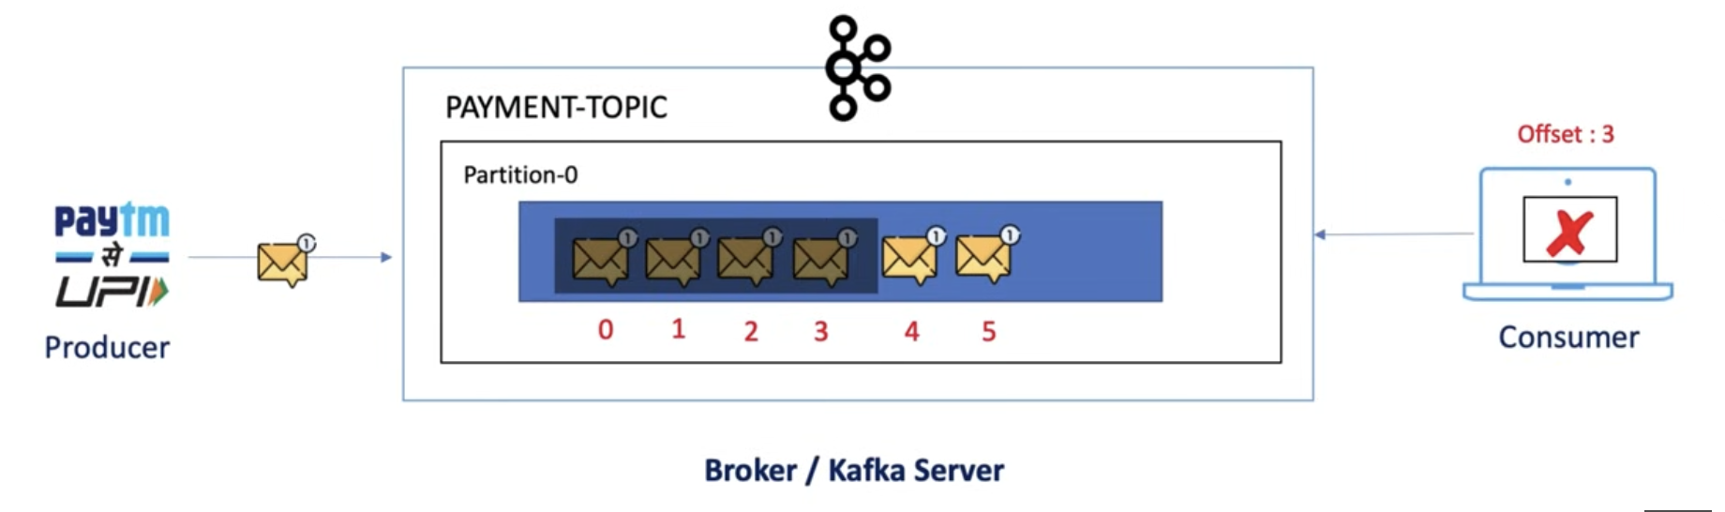

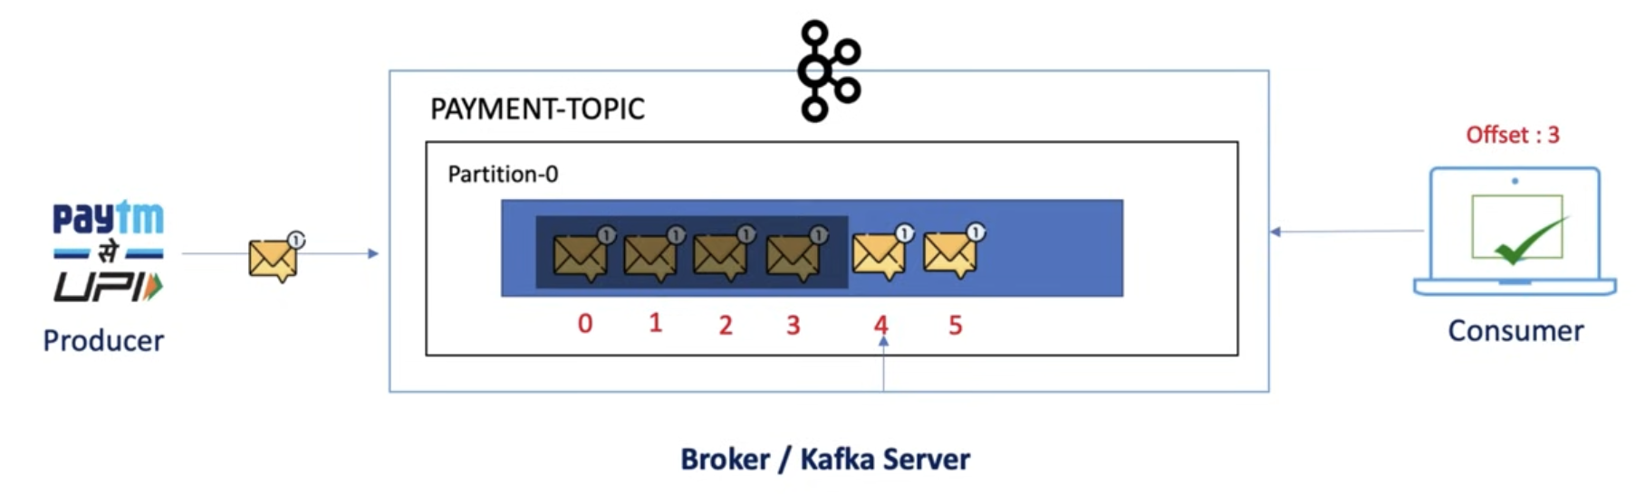

**Offset**

* When producer send a message then it goes and sit in any partition inside topic that we don’t have any controller need, it works based on round-robin principle, so as soon as arrive the message the number is assigned to that message and these number is called **offset**. It is sequence number assigned to each message in each partition of a kafka topic.

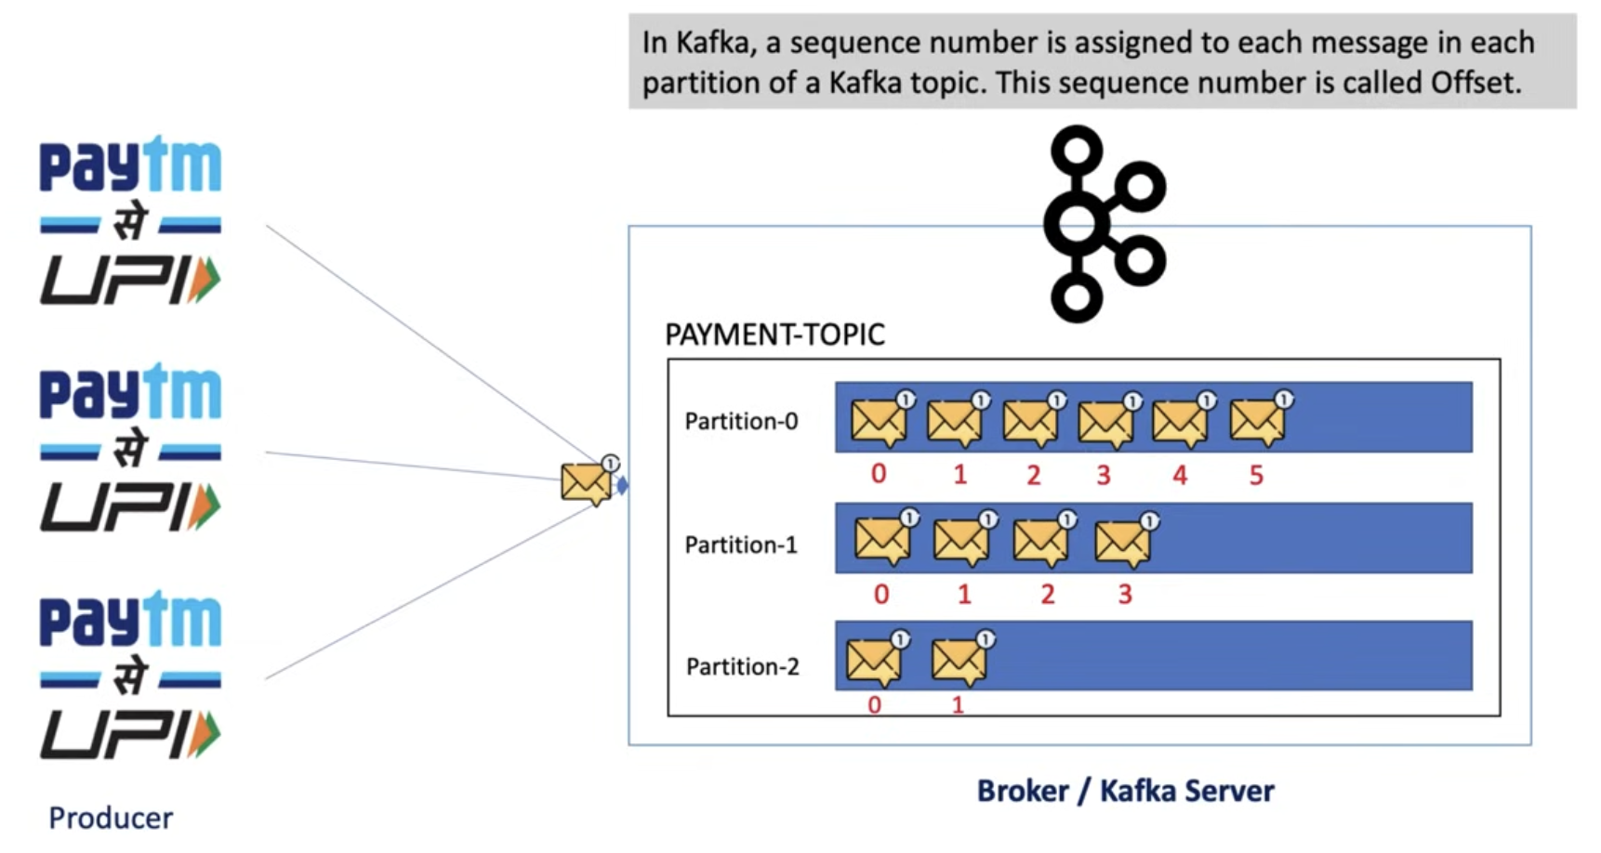

**Why consumer-group?**

* I have 3 partition, and single consumer is reading each and every partition which is defiantly lead the performance issue because there is no concurrency, to overcome this issue consumer-group come into picture, I have payment_consumer_group which are having 3 consumer and we can dive the work load to each and every consumer to achieve better performance.
* We cannot grantee a consumer and partition order like any consumer can read the message from any partition.
* Hey I have 3 partition and 3 consumer and they can are talk to each other that’s fine but what if I have 4th consumer added to the consumer group then what you will do for him, the consumer-4 sit ideal because there is no work for him now since all 3 partition assign to 3 different consumer instance there is no partition left for him but in case any consumer instance rejected or goes off then ideal consumer get chance to connect with partition, and this concept is called **consumer rebalancing.**

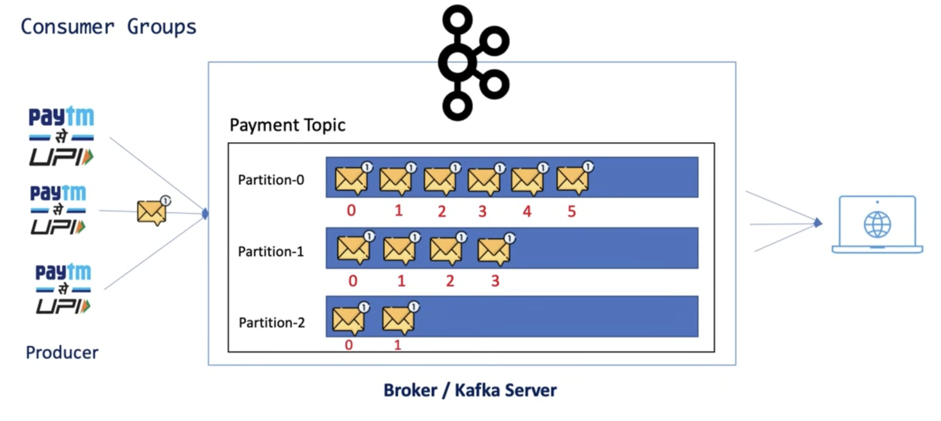

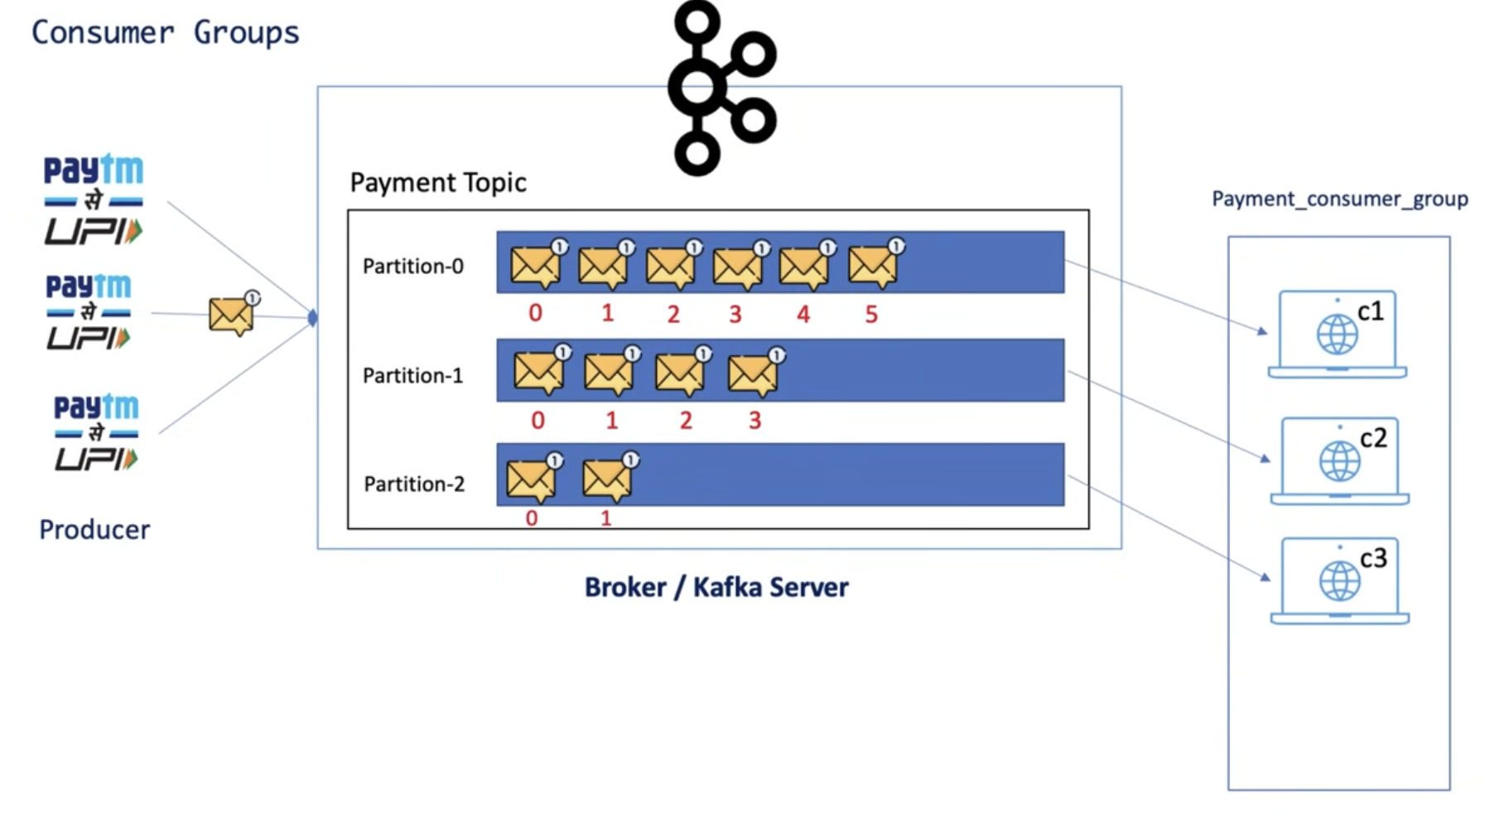

**Zookeeper**

* kafka is distributed system and it usages zookeeper for coordination and track the status of kafka cluster (kafka topic, partition, offset)
* It acts as manager for kafka cluster.

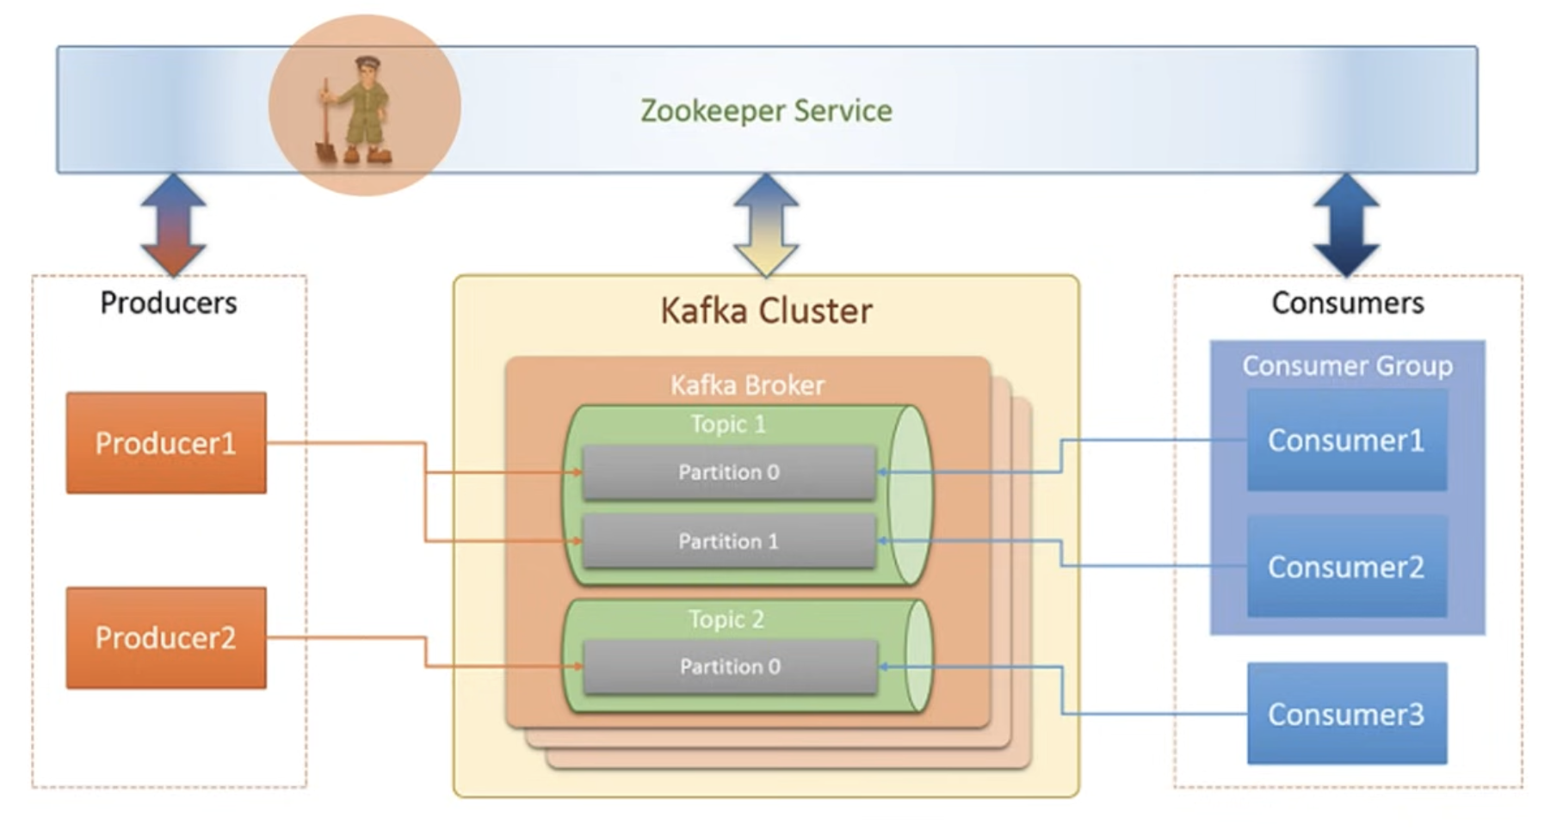

**Note**:

Once producer send the message there is no grantee that message goes to partition 0 or 1 or 2…, so this message managing by **zookeeper** and **coordinator (**Kafka scheduler**)** like which message goes to which partition.

If producer send the simple string message, then not required to do the sterilization/deserialization configuration in .yml file because SpringBoot auto detect this to do the job(sterilization/deserialization) but if you want to send java object then in this case you have to do the sterilization/deserialization configuration in .yml file, kafka only store **byte arrays** (byte[]).

We can do the configuration (sterilization/deserialization/ bootstrap-server/topic….) in application.properties / application.yml or java configuration using bean, if you they simply produce or consume the message then application.yml is good but if you want to access secure kafka cluster or any customization then in this case java configuration approach is good because you cannot write the certification configuration in .yml file.

**To start individual service:**

Commands – Navigate to the path where the **kafka** is located and then run the below command.

1. Start Zookeeper Server

bin/zookeeper-server-start.sh config/zookeeper.properties

1. Start Kafka Server / Broker

bin/kafka-server-start.sh config/server.properties

1. Create topic

bin/kafka-topics.sh --bootstrap-server localhost:9092 --create --topic NewTopic --partitions 3 --replication-factor 1

1. list out all topic names

bin/kafka-topics.sh --bootstrap-server localhost:9092 --list

1. Describe topics

bin/kafka-topics.sh --bootstrap-server localhost:9092 --describe --topic NewTopic

1. Produce message
2. bin/kafka-console-producer.sh --bootstrap-server localhost:9092 --topic NewTopic
3. consume message

bin/kafka-console-consumer.sh --bootstrap-server localhost:9092 --topic NewTopic --from-beginning

**To start all services in one file:**

Commands - Navigate to the path where the docker-compose.yml is located and start docker desktop and then run the below command.

1. Start all services

docker compose -f docker-compose.yml up -d

1. Let’s go to container by running the below command

docker exec -it kafka /bin/sh

1. Create the topics

kafka-topics.sh --bootstrap-server localhost:9092 --create --topic quickstart --partitions 3 --replication-factor 1

1. Producer message

kafka-console-producer.sh --bootstrap-server localhost:9092 --topic quickstart

1. Consumer message

kafka-console-consumer.sh --bootstrap-server localhost:9092 --topic quickstart --from-beginning

How can producer send the message to specific partition(2) and consumer read that partition message?

**Producer**

CompletableFuture<SendResult<String, Object>> future = kafkaTemplate.send("my-topic", 2, "myKey", message);

**Consumer**

@KafkaListener(topics = "my-topic", groupId = "jt-group",

topicPartitions = {@TopicPartition(topic = "my-topic", partitions = {"2"})})

public void consume (String message) {

log.info("consumer consume the events {}", message);

}

In Kafka, how to send the message synchronously?

SendResult<String, Object> result = kafkaTemplate.send("my-topic", message).get();

**Error Handling – retry and DLT**

* When producer send the message and process the message from kafka topic then Error can occur related to consumer instances or DB connection might be unavailable (like if producer send the event for DB connection and during that time DB server is down then error can occur and this case might lose the event, so if that event try to invoke multiple time it might get the connection) during the period so in that case risk of losing any event send or received due to failure.

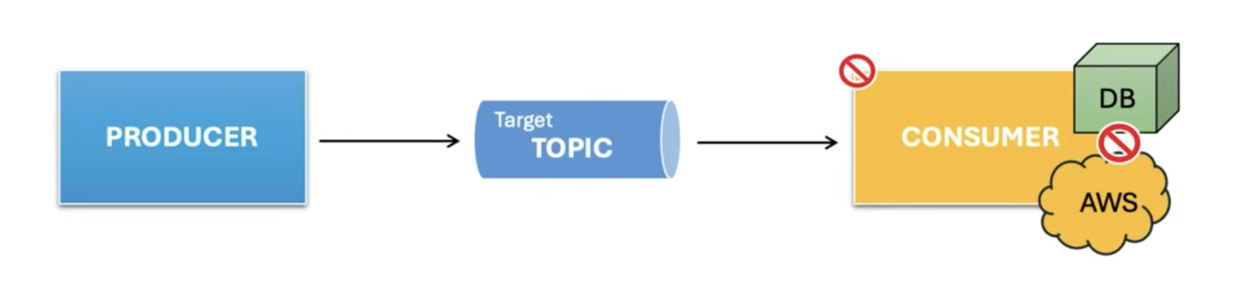

* Consider you processing financial transaction and if transaction fail due to some temporary issue, then how will you handle it because need to ensure the reliable message processing, so to handle this we instruct kafka to retry the failed event so kafka simply re-attempt the process the message multiple time as per your configuration, example if you set up retry count to 4 kafka will make 3 retry attempt in a sequential order because it follow n-1 order. next if the process success within the retry attempt then its good however if retry attempt is exceeded then it directed to DLT(Dead Letter Topic). DLT – It store fail message, why DLT because we are having the copy of fail event so in future can investigated and reprocess it if required.

